Object-Oriented Programming (OOP) – Complete Notes

🔹 Introduction to OOP
- Object-Oriented Programming (OOP) is a programming paradigm where the program is designed around objects.
An object is a real-world entity (or its software representation) that stores data and performs actions on that data.
Think of an object as “data + actions together”.

🔹 Object has TWO main things
1️⃣ Properties (State) → Data Members
These represent what the object has.
- Stored as variables inside a class
- Describe the current state of the object
📌 Examples:
- A Car has → color, speed, fuel
- A Student has → name, roll number, marks

2️⃣ Behaviors (Functions) → Member Functions
These represent what the object can do.
- Stored as functions inside a class
- Operate on the object’s data members
📌 Examples:
- A Car can → start(), accelerate(), brake()
- A Student can → study(), giveExam(), displayDetails()

- Goal of OOP:
  - Make programs closer to real-world modeling
  - Improve:
    - Readability
    - Maintainability
    - Extensibility (easy to add new features)

🔹 C++ Example
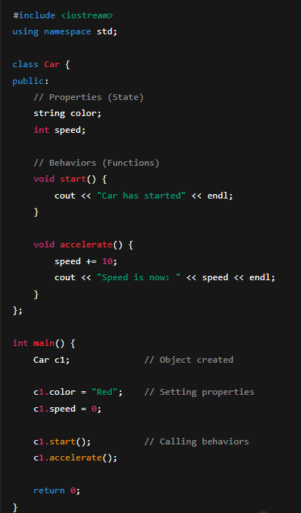
🔹 What happened here?
✔️ Car → Class
- Blueprint / template

✔️ c1 → Object
- Actual entity created from the class

✔️ Data Members (Properties / State)
string color;
int speed;

✔️ Member Functions (Behaviors/ Functions)
start();
accelerate();

🔹 Classes and Objects
📌 Class
- A class is a user-defined data type
- It acts as a blueprint / template for creating objects
- Defines:
  - Data members (properties)
  - Member functions (behaviors)

📌 Object
- An object is an instance of a class
- Created using the class name
Example:
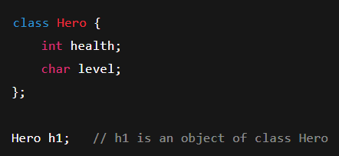
🔹 Size of an Object
👉 The size of an object depends only on its data members
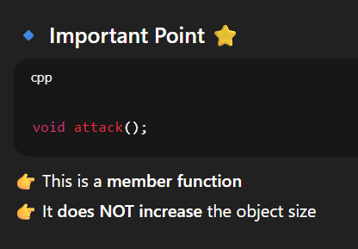
❌ Member functions are NOT included in the object size
❓ Why?
- Functions are created only once in memory for the class
- All objects share the same functions
- So, functions are not stored separately for each object

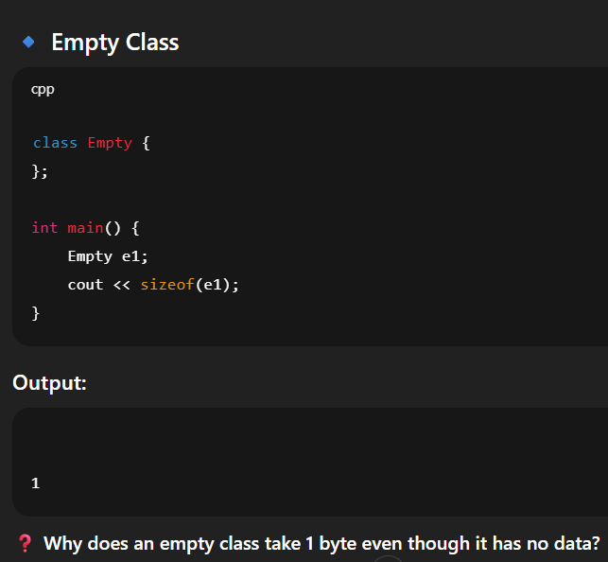
🔹 Reason: Empty Class Size = 1 Byte
1️⃣ Object Identification
- The compiler must be able to identify each object
2️⃣ Memory Tracking
- Every object must occupy some memory space
3️⃣ Unique Object Address
- Each object must have a unique address
- If size were 0:
  - Two objects could end up with the same address ❌

How compiler decides size (STEP-BY-STEP)
- Place first variable
- Check next variable alignment
- Add padding if needed
- Repeat
- At end → add padding so total size is multiple of largest type

Important Interview Traps ⚠️
Padding wastes memory? Yes, but improves CPU performance
Member functions cause padding? NO, Only data members affect size
Padding is optional? NO It is mandatory for alignment

One-Line Interview Answers
Padding is the extra memory added by the compiler to align data members properly in memory.
Alignment ensures data types start at memory addresses suitable for efficient CPU access, usually multiples of their size.
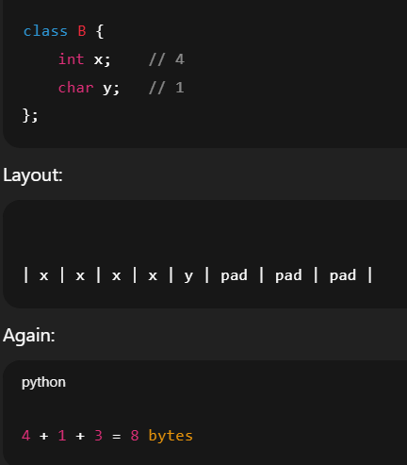
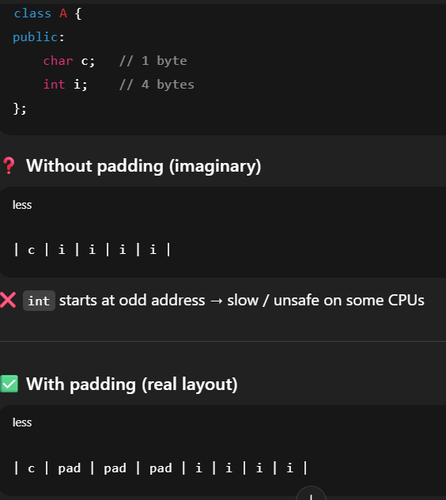

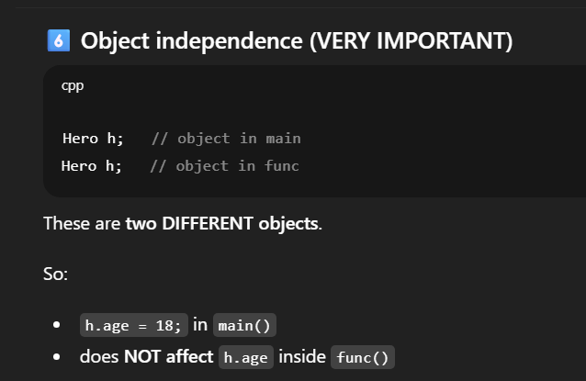
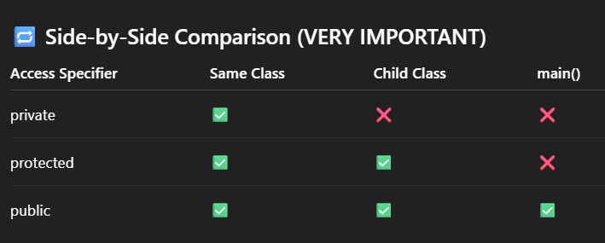
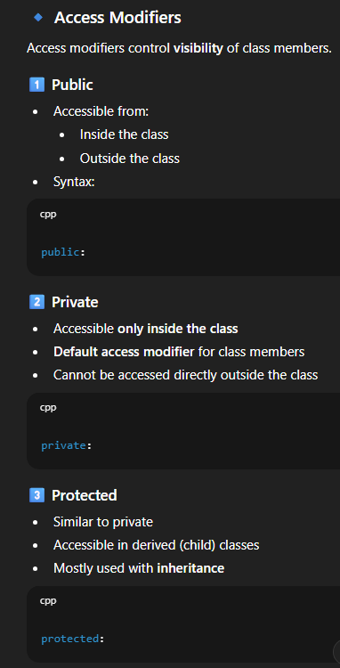
🔹 Getters and Setters
- Used when data members are private
📌 Getter Retrieves the value of a private data member
📌 Setter Modifies the value of a private data member and can include validation logic

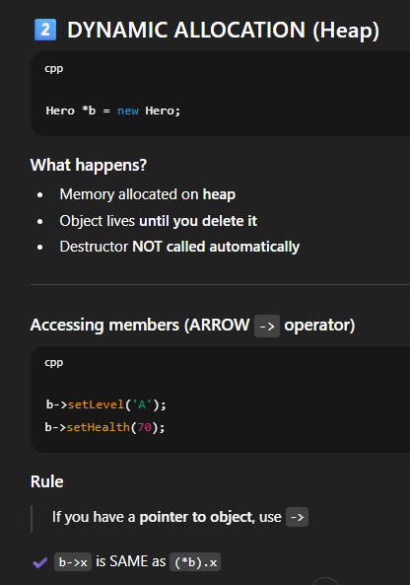
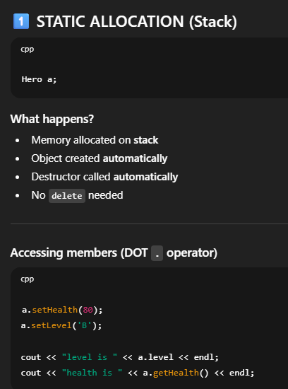

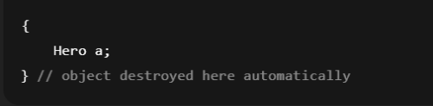

🔹 Constructors
- Special member function
Properties of Constructor
- Same name as class
- No return type (not even void)
- Called at object creation time
📌 Default Constructor
- Automatically called when object is created

📌 Simple Constructor
- Constructor with no parameters
- If no constructor is defined, compiler provides one
- If any constructor is defined, compiler does not provide default constructor
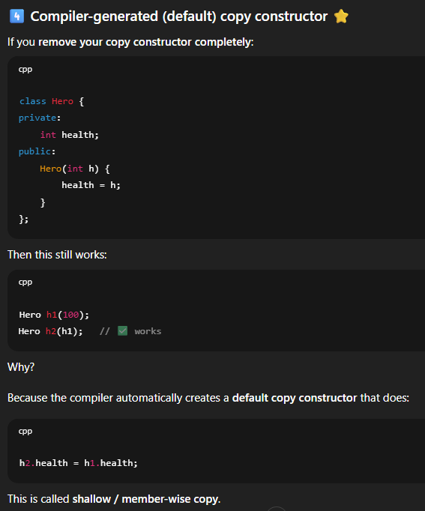
📌 Parameterized Constructor
- Constructor with parameters
- Used to initialize object data at creation time

📌 Copy Constructor
- Used to create a new object as a copy of an existing object
- Called during object creation
- If not defined, compiler provides a default copy constructor

🔹 this Keyword
- this is a pointer to the current object
- this is a pointer that stores the address of the object that is calling the function.
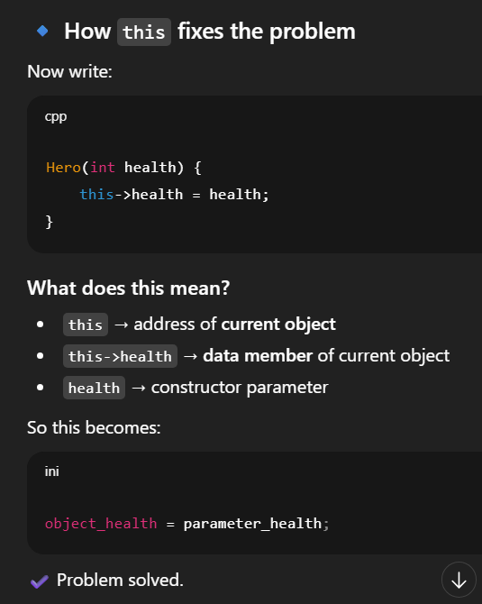
- this is an implicit pointer that points to the calling object and is used to differentiate between data members and local variables with the same name.
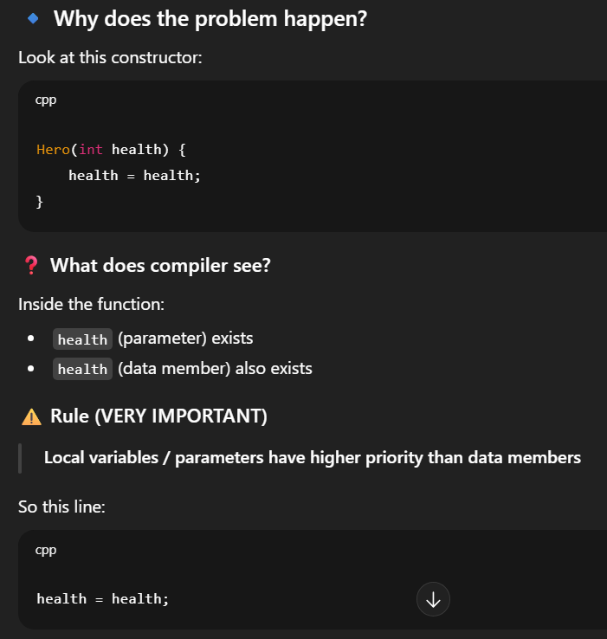


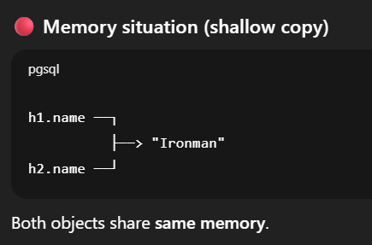
📌 Shallow Copy
- Default behavior
- Shallow copy copies only the memory address, not the actual data.
- Multiple objects point to same memory
- Changes in one object affect others
⚠️ Dangerous when pointers are involved
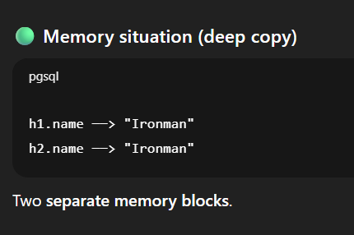
📌 Deep Copy
- Deep copy allocates new memory and copies the actual data.
- Each object has its own memory
- Objects are fully independent

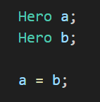
🔹 Assignment Operator (=)
- Used to assign one existing object to another existing object
- Different from copy constructor Default assignment operator performs shallow copy
- It will be done only after successfully creating the 2 objects
- It copies the value of b into a
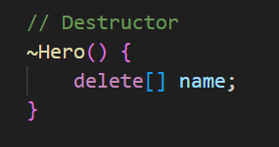
🔹 Destructor
- Special member function
- Automatically called when object is destroyed
- Used for cleanup and memory deallocation
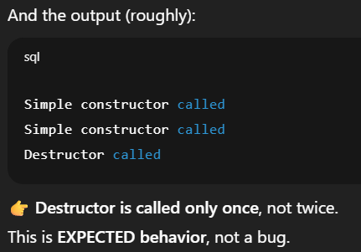
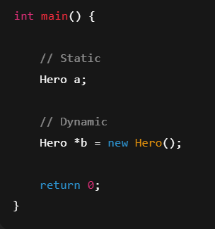
Properties
- Same name as class
- Prefixed with ~
- No parameters
- No return type
Destructor Call
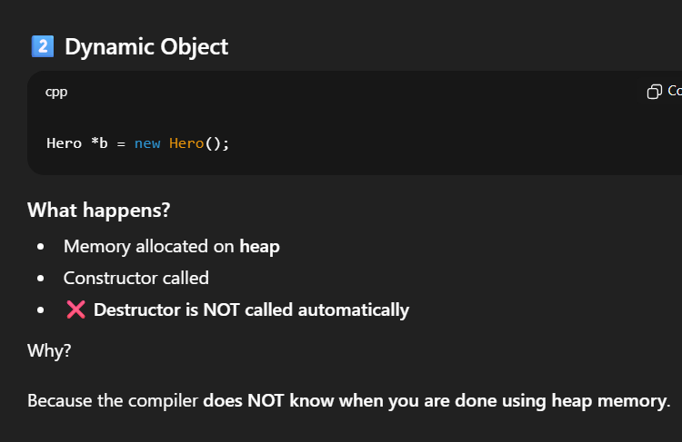
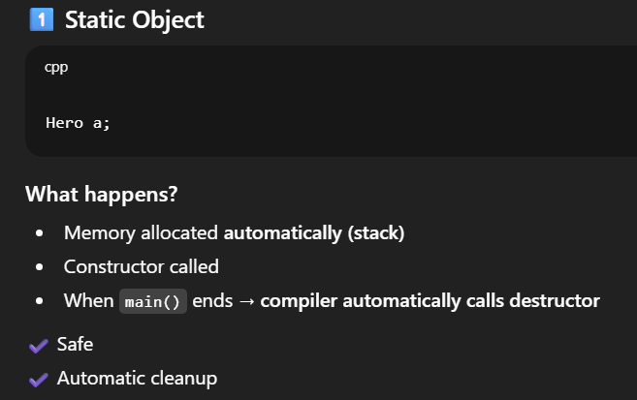
📌 Static Data Members
• Belong to the class, not to individual objects
• Not required to make object
• Only ONE copy exists in memory
• Shared among all objects of the class
• Declared inside the class
• Defined & initialized outside the class
• Accessed using :: (scope resolution operator)

📌 Static Functions
- Belong to the class
- Not required to make object
- this pointer cannot be used
- Can access only static members

📌 What is an Initializer List?
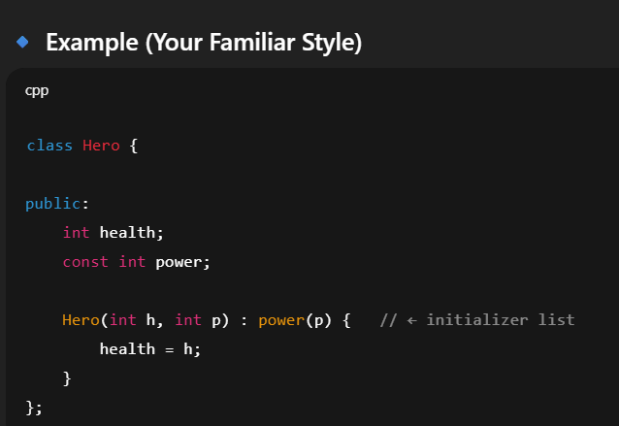
Initializer list is a way to initialize data members of a class before the constructor body executes.
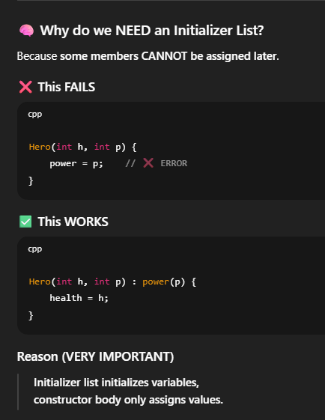
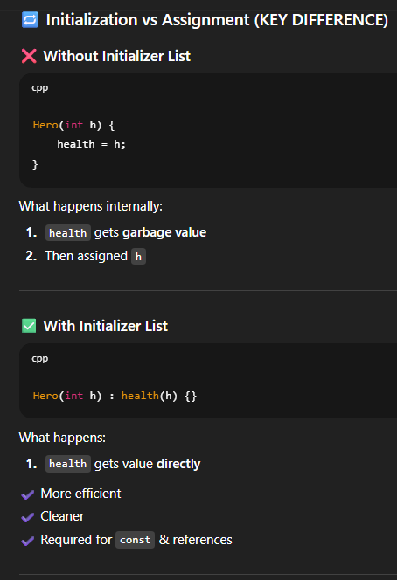
📌 const Data Members
• Value cannot be changed after initialization
• Must be initialized at object creation
• Initialized using constructor initializer list
• Each object can have a different const value
• Belong to the object (not shared)
• Improve data safety (read-only data)

📌 const Member Functions
• Guarantee object data will not be modified
• Can be called on const objects
• Cannot modify non-mutable data members
• this pointer becomes const
• Read-only access to data members

📌 const Objects
• Object declared as read-only
• Can call only const member functions

📌 static const Data Members
• Belong to class, not object
• Single shared copy
• Must be initialized outside class
- static → belongs to class
- const → value cannot change
👉 So: One fixed value shared by all objects

1. Encapsulation (Encapsulation = Data hiding + controlled access using methods)
Encapsulation means wrapping data members and member functions into a single unit, usually a class.
📦 Capsule analogy
- Capsule → Class
- Medicines inside → Data members + Functions
All things related to one entity are packed together.

🔐 Fully Encapsulated Class
A class is called fully encapsulated when:
- All data members are private
- Access is provided only through public methods (getters/setters)

❓ Why Encapsulation?
1️⃣ Information Hiding
- Internal data is hidden
- User sees only what is necessary
- Implementation can change without affecting user code

2️⃣ Increased Security
- Direct access to variables is restricted
- Data cannot be modified accidentally

3️⃣ Read-Only Functionality
- If only getter is provided
- Object becomes read-only
- If we want, we can make the class read only

4️⃣ Reusability
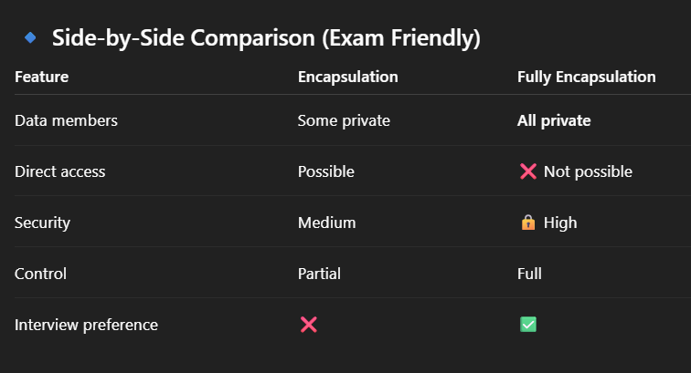
- Encapsulated classes can be reused
- Used in multiple programs/modules

5️⃣ Testability
- Isolated code is easier to test
- Bugs are easier to locate
2. Inheritance (👉 Inheritance = Reusing properties and functions of an existing class)
Inheritance allows a child class to acquire from a parent class.
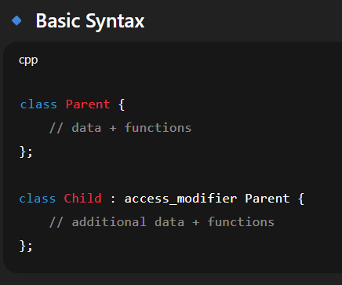
- Properties (data members) and Behaviors (member functions)
❌ Private members of a parent class are NOT inherited
They exist in memory but cannot be accessed directly in child classes.

🔹Parent & Child Terminology
Parent / Super Class Class being inherited from
Child / Sub Class Class that inherits

🔹 Modes of Inheritance
The mode of inheritance decides how accessible parent members become in the child.
Access Transformation Table
Parent Member | Public Inheritance | Protected Inheritance | Private Inheritance
Public | Public | Protected | Private
Protected | Protected | Protected | Private
Private | ❌ Not accessible | ❌ Not accessible | ❌ Not accessible
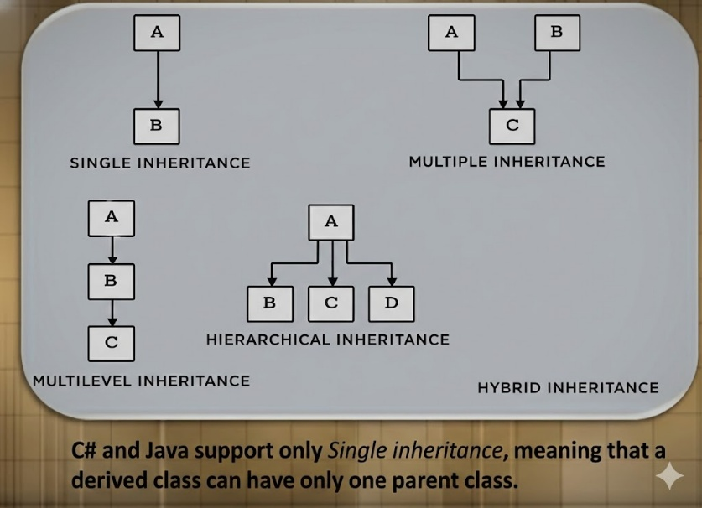
🔹Types of Inheritance
1️⃣ Single Inheritance
One child inherits from one parent.
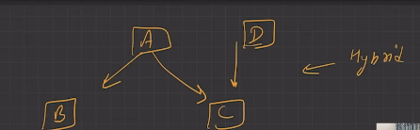
2️⃣ Multi-Level Inheritance
Inheritance in a chain.

3️⃣ Multiple Inheritance
One child inherits from multiple parents.
⚠️ Problem: If both parents have the same function → ambiguity

4️⃣ Hierarchical Inheritance
Multiple children inherit from one parent.

5️⃣ Hybrid Inheritance
Combination of two or more inheritance types.

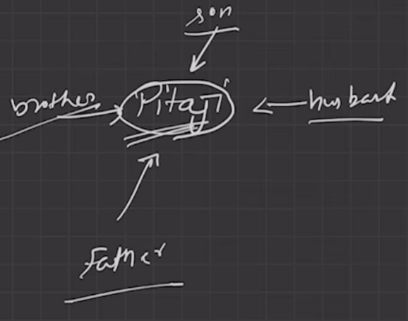
3. Polymorphism (Polymorphism = Many Forms)
Same function name behaves differently in different situations.

🔹 TYPES OF POLYMORPHISM
- Compile-Time Polymorphism
- Run-Time Polymorphism

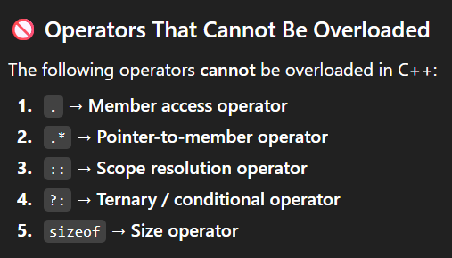
🔹 Compile-Time Polymorphism (Static polymorphism)
Resolved at compile time and decision made by compiler
1️⃣ Function Overloading
Same function name, different parameters.
2️⃣ Operator Overloading
Gives new meaning to operators. Used for user-defined data types

🔹 Run-Time Polymorphism (Dynamic polymorphism)
Resolved at run time. Decision made while program is running
Method Overriding
👉 Meaning
- Same function name
- Same parameters
- Different class (parent & child)
- Requires virtual function

4. Abstraction (abstraction = implementation hiding )
Abstraction means:
- Showing only essential features
- Hiding complex implementation details
- User knows WHAT to do, not HOW it is done

Real-Life Example: Sending an Email
When you send an email, what do you actually see?
👤 What the User Sees (Abstraction)
- Write email
- Click Send button
That’s it ✔️
You do NOT see:
- Server connection
- Authentication
- Encryption
- DNS lookup
- Packet transfer
- Error handling
➡️ All these are hidden from the user

🔗 Relation Between Encapsulation & Abstraction
- Private data + public interface = abstraction

🔒 How Encapsulation Helps Abstraction
🔗 Relation Between Encapsulation & Abstraction
Encapsulation | Abstraction
Wrapping data + methods | Hiding implementation
Uses access specifiers | Shows only required info
HOW to hide | WHAT is hidden
👉 Encapsulation is a tool
👉 Abstraction is the result

🔷 What Is the Diamond Problem?
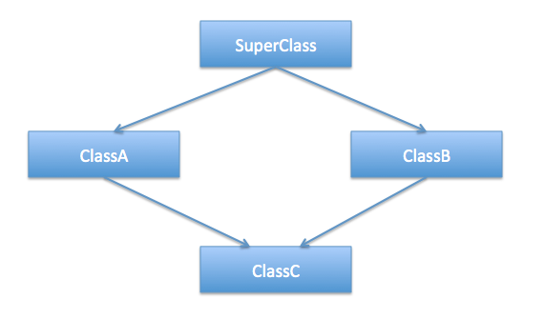
The Diamond Problem is an ambiguity problem in C++ that occurs in multiple inheritance when the same base class is inherited more than once through different paths.
It is called diamond because the class structure looks like a diamond.

❌ What Is the Problem?
Class D gets two copies of class A, one through B and one through C.
So when you try to access members of A using D, the compiler gets confused:
“Which A should I use? The one from B or the one from C?”
This confusion is the Diamond Problem.

✅ Solution: Virtual Base Class
Use the keyword virtual when inheriting the base class.
This ensures only ONE copy of A exists.

📌 Key Points (Exam Ready)
- Diamond problem occurs in multiple inheritance
- Same base class is inherited twice
- Causes ambiguity
- Solved using virtual base class
- Virtual inheritance ensures single shared copy

